**Submitted by: Submitted to:**

**NAME: Rahul Gusain Dr. Hitesh Kumar Sharma**

**SAP: 500084143**

**ROLL NO.: R214220900**

**BATCH: 1 DevOps**

# Build and Release Management

**LAB EXERCISE 8**

**Aim:** Build Docker Image and Push on DockerHubCreate a Docker Image and Push on DockerHub.

**Step 1** − Search for Docker Playground on google and click on the first link that appears.Log in using the Dockerhub account and then click on Start.

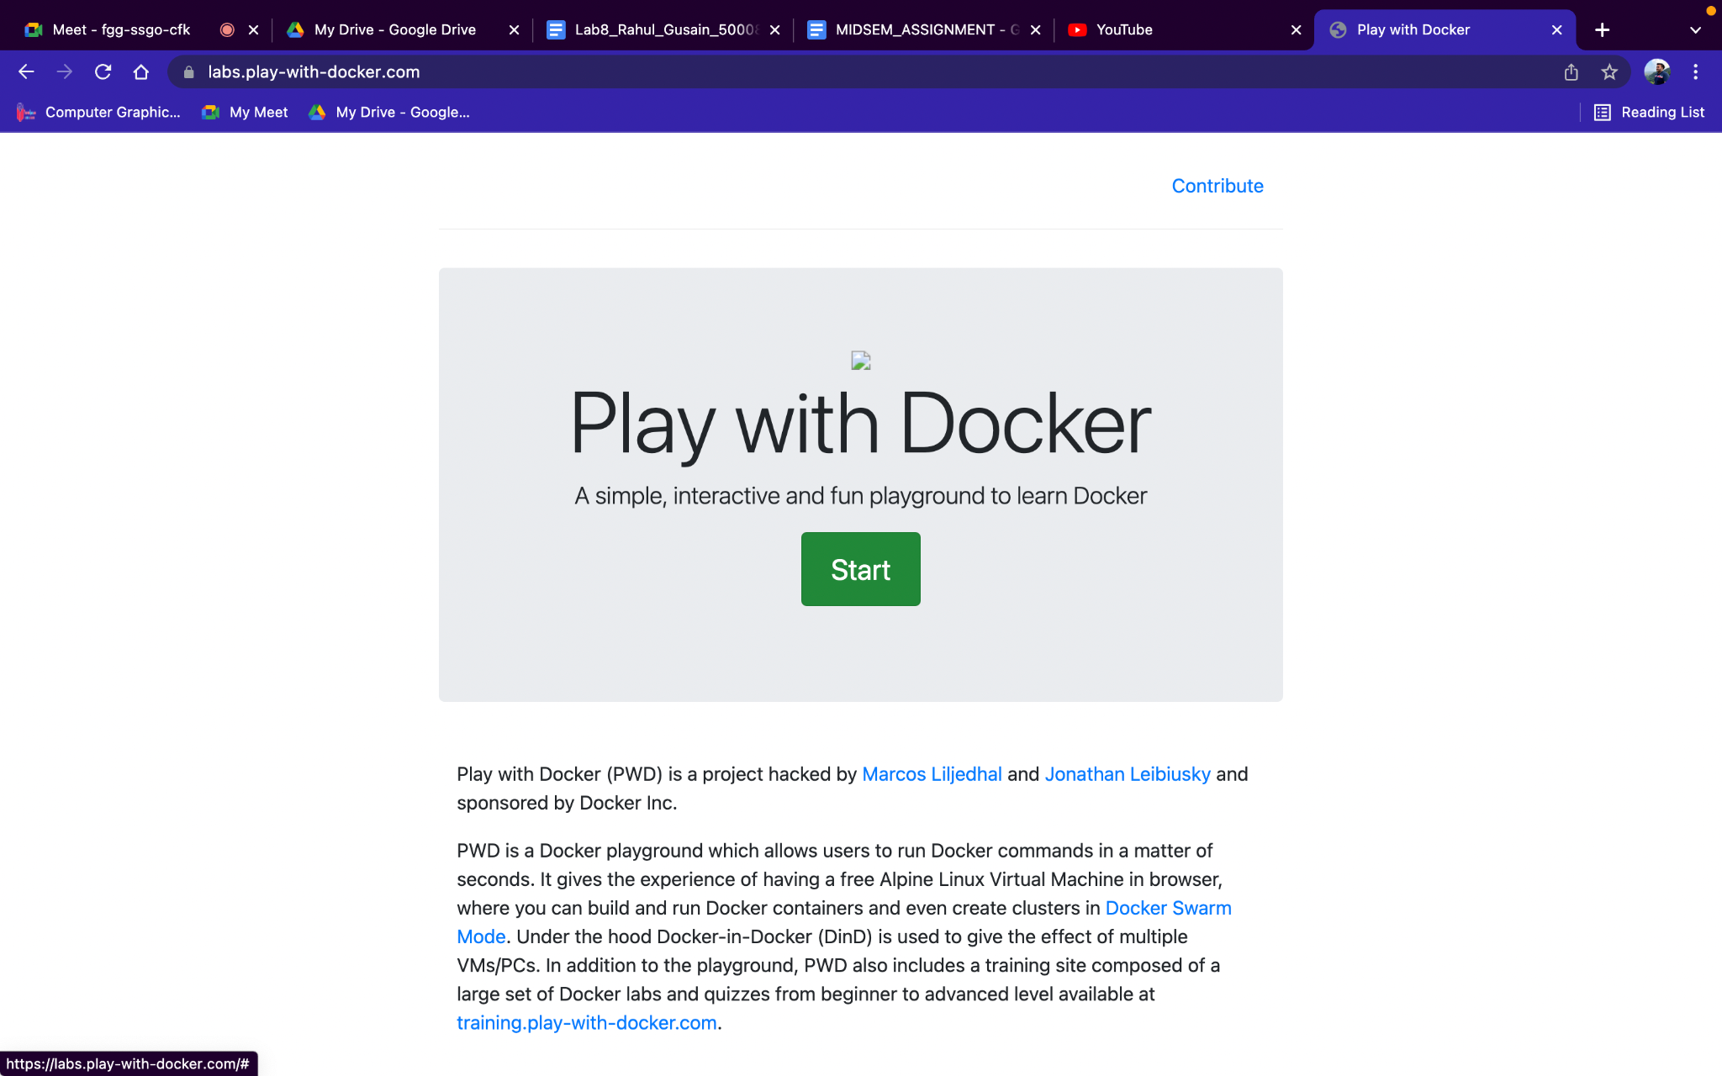

**Step 2**− Click on Add new instance and then on the terminal that appears create a file called **Docker File** and edit it using **vim**. Please note that the name of the file has to be"Dockerfile" with "D" as capital.

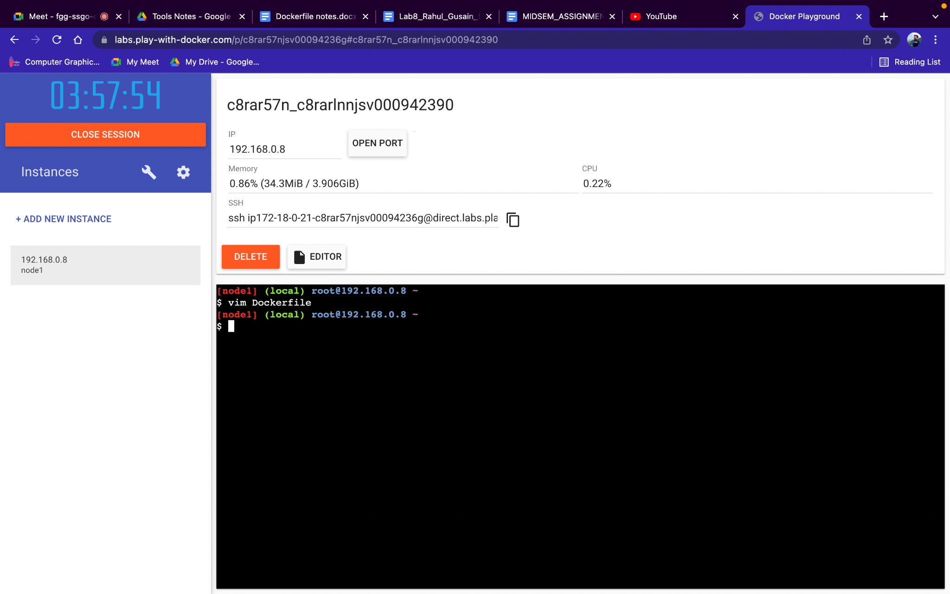

**Step 3**− Click on EDITOR and then type the required things in the file.

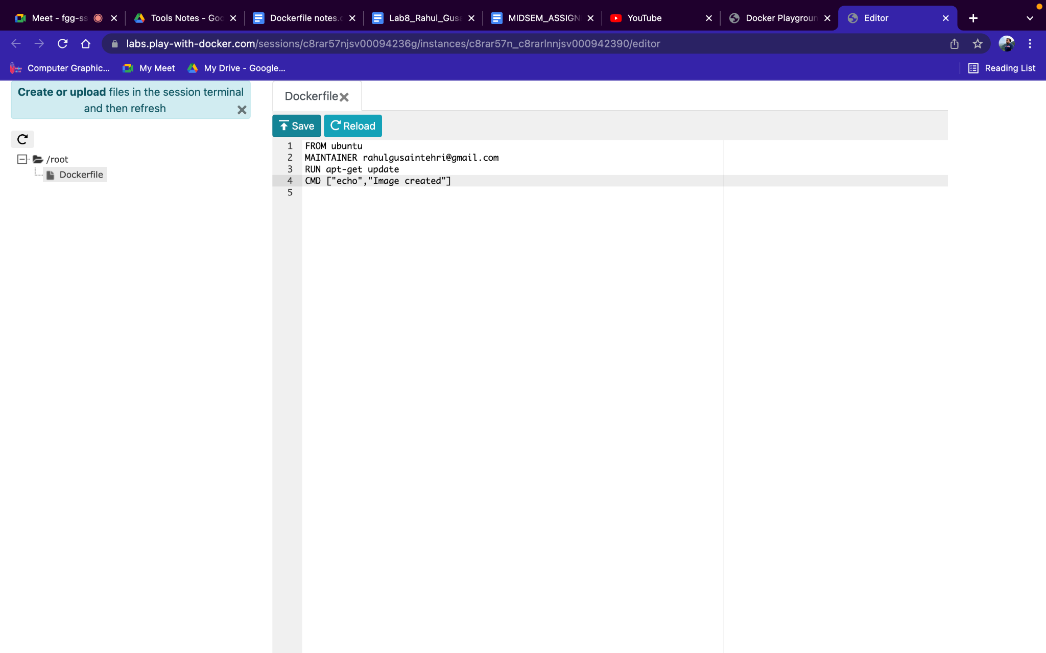

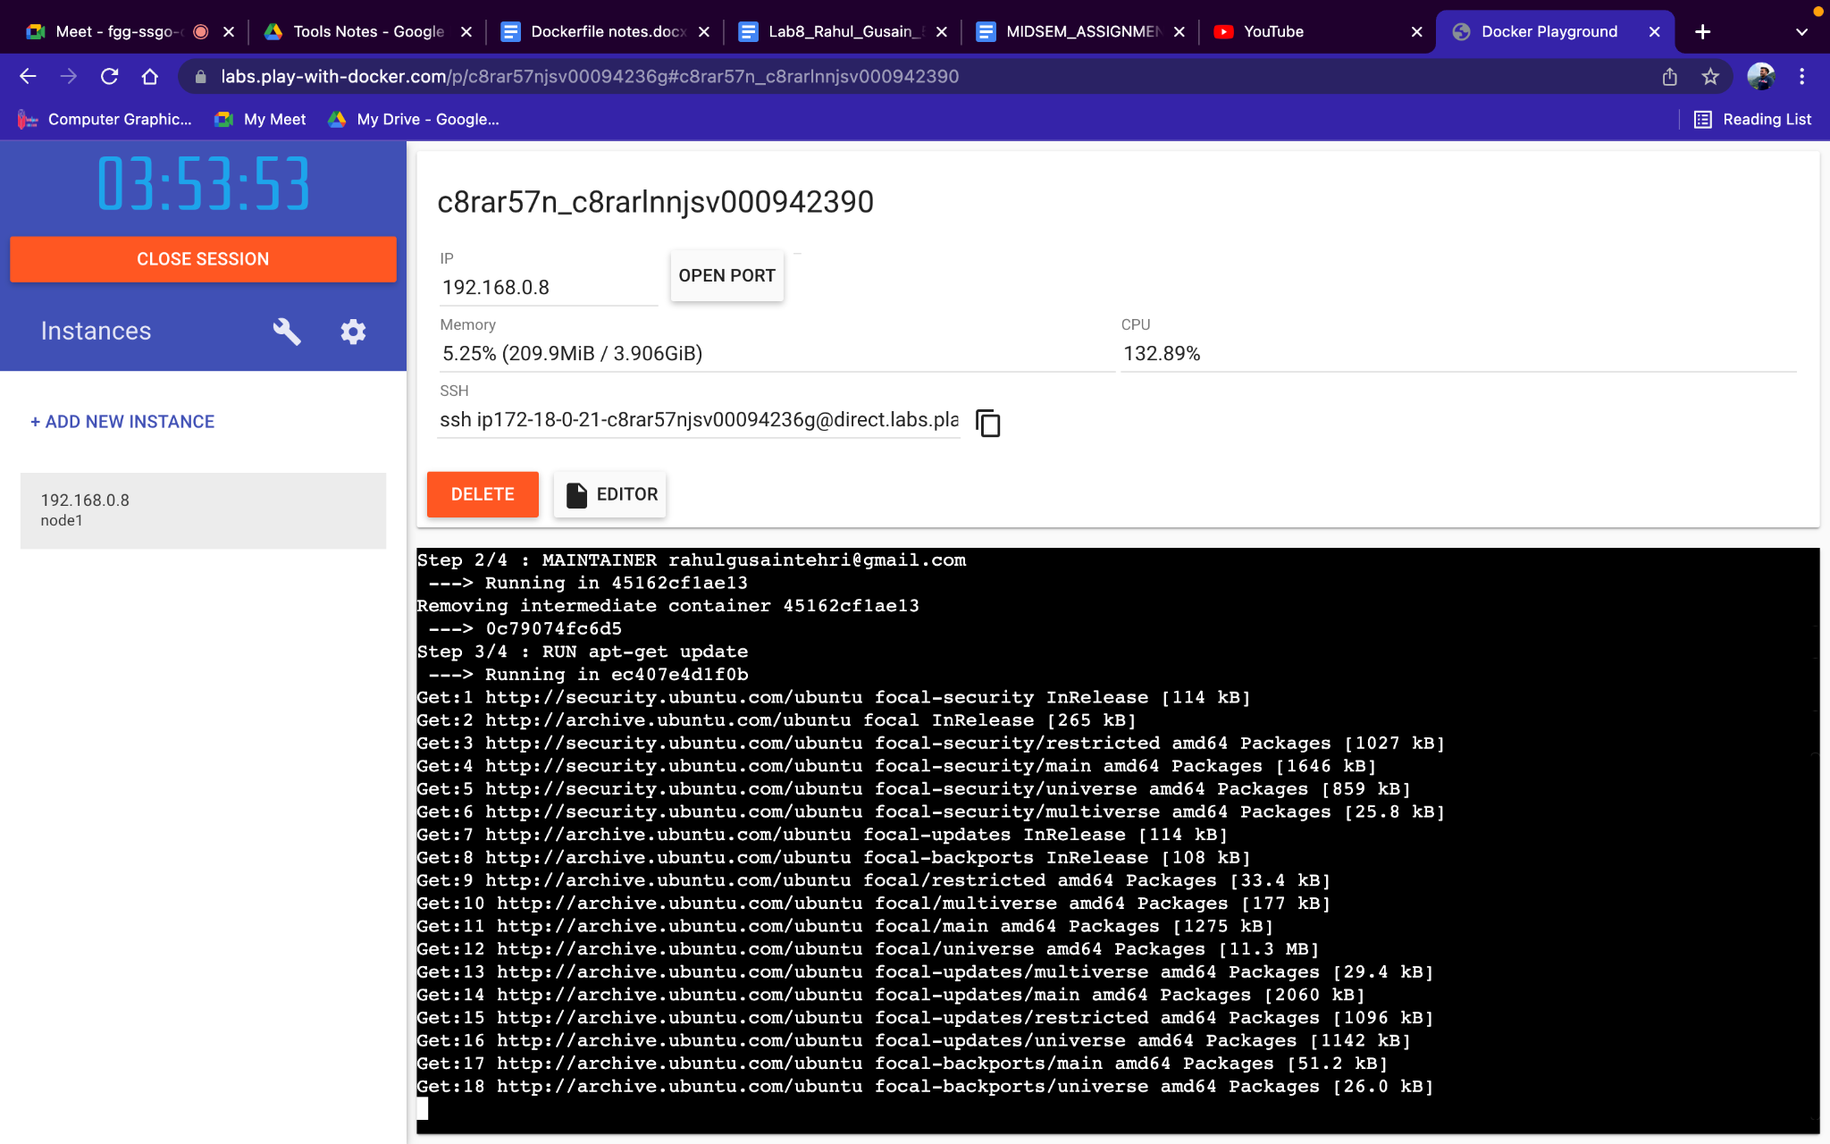

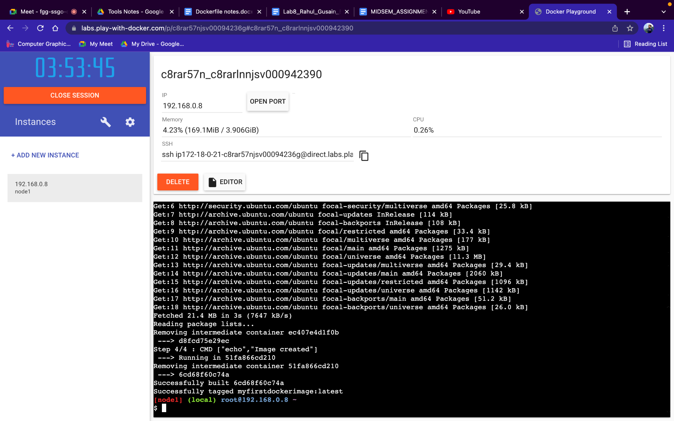

**Step 4-** Check for all the images using docker images command.It will show myfirstdockerimage repository which we have recently created.

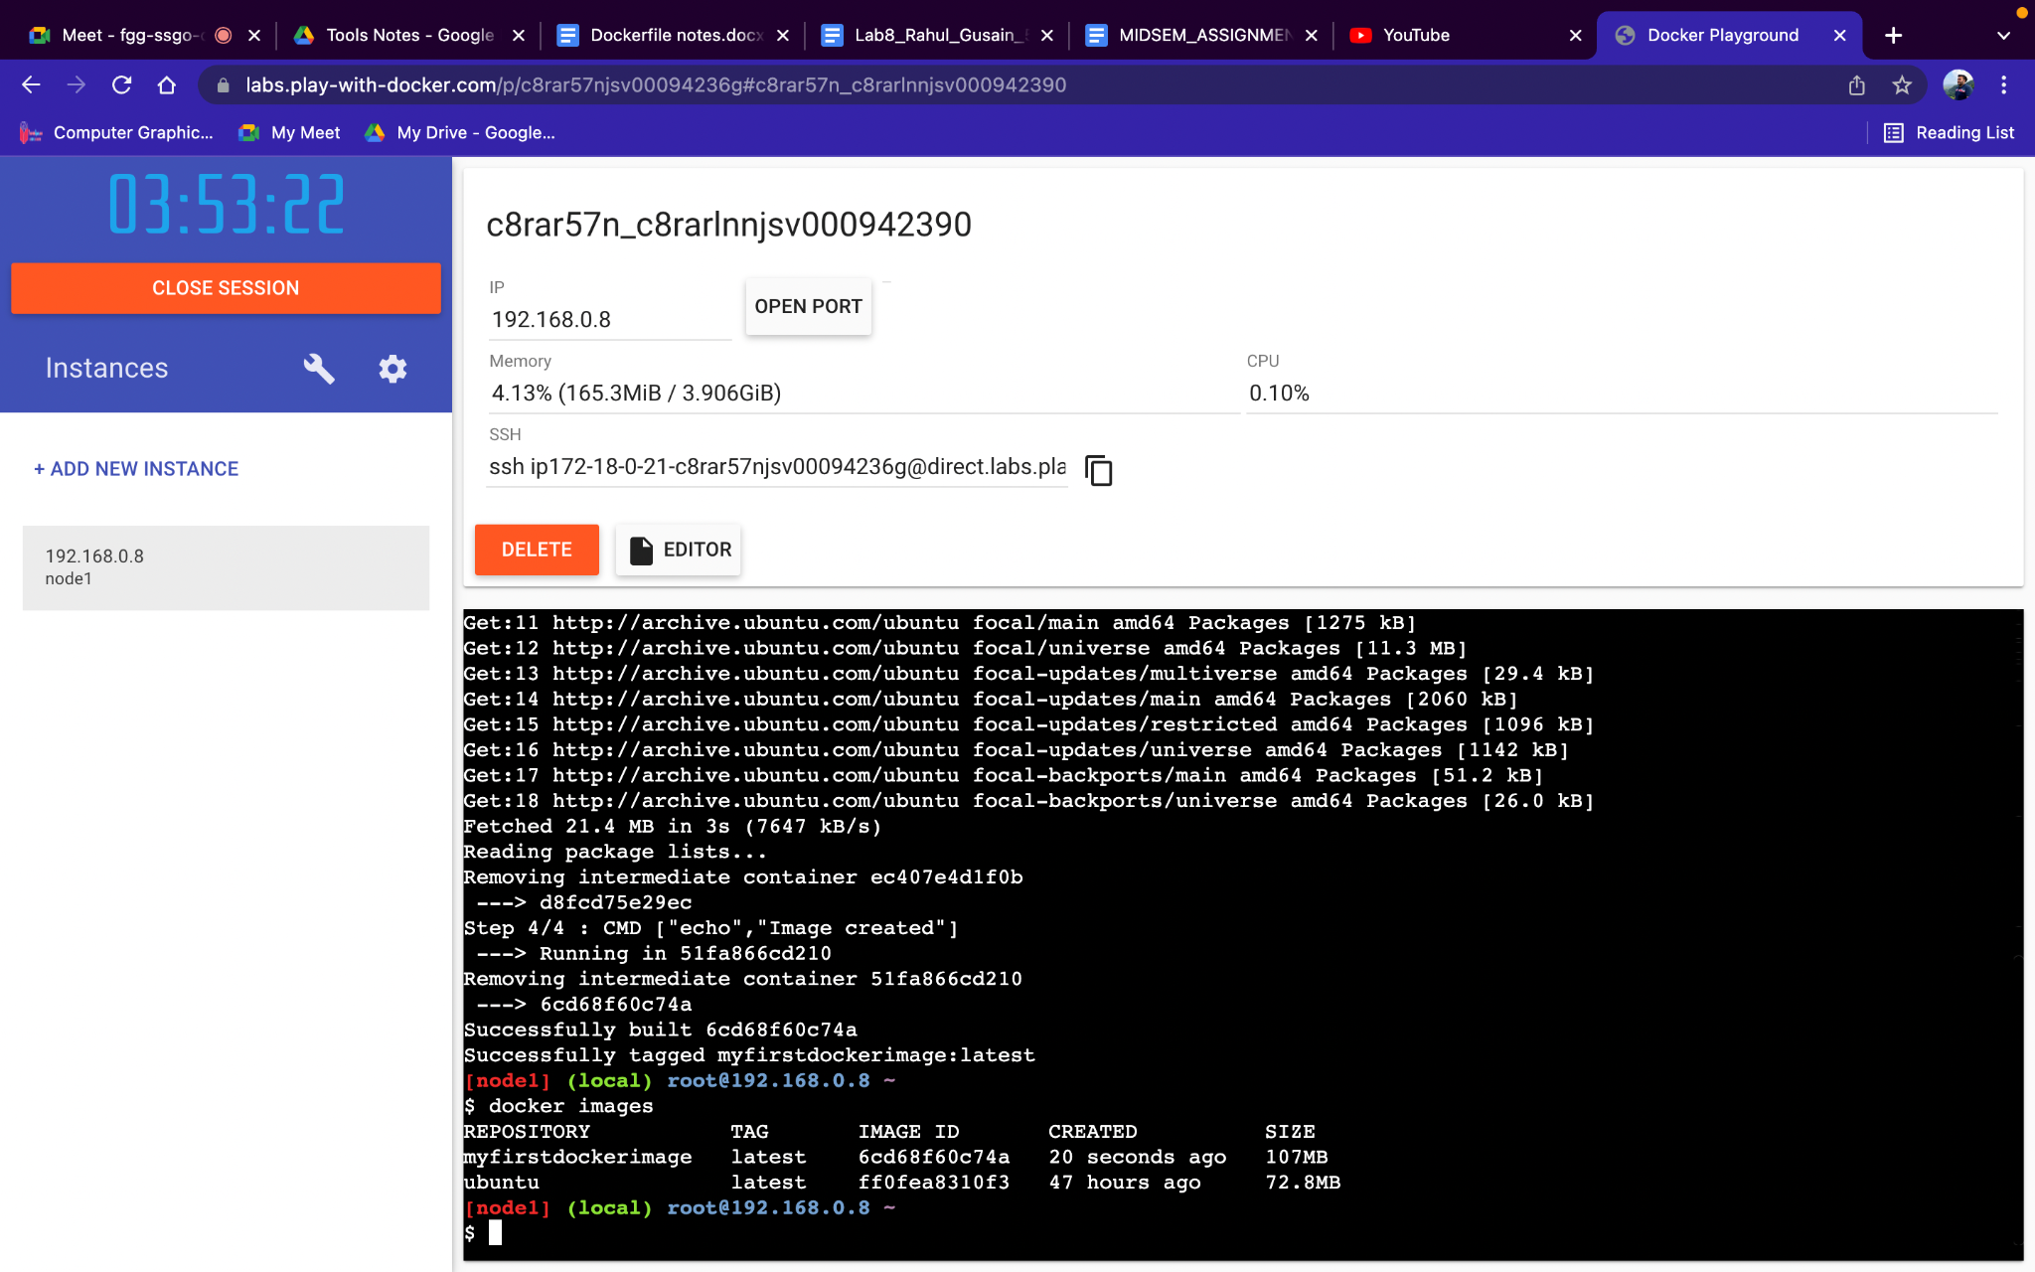

**Step 5**− Use docker login command to connect this instance to our dockerhub account by providing the username and password and it will show login succeeded.

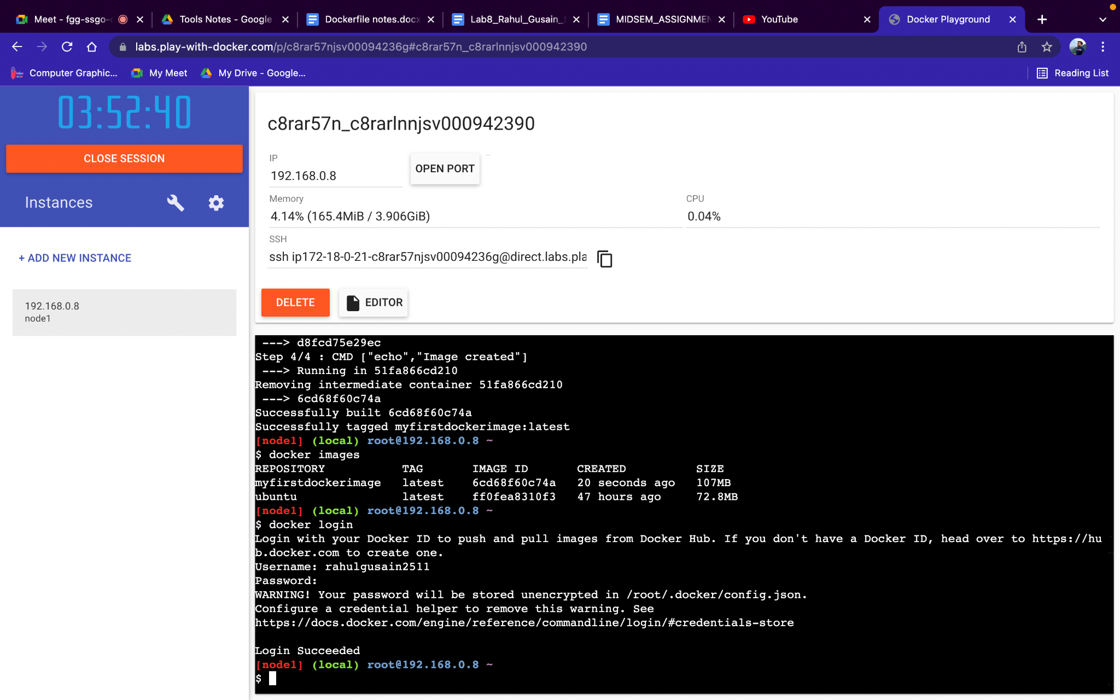

**Step 6**− Use docker tag command to tag our image.

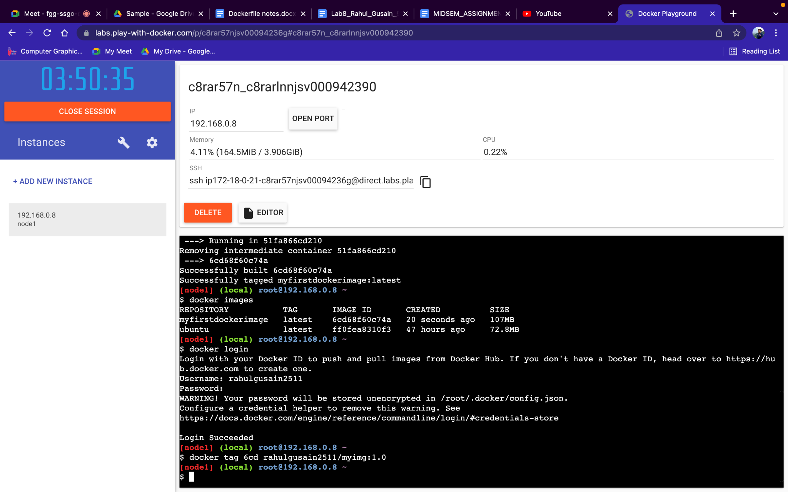

**Step 7**− Use the command docker images to see whether our image is tagged with a new name or not.

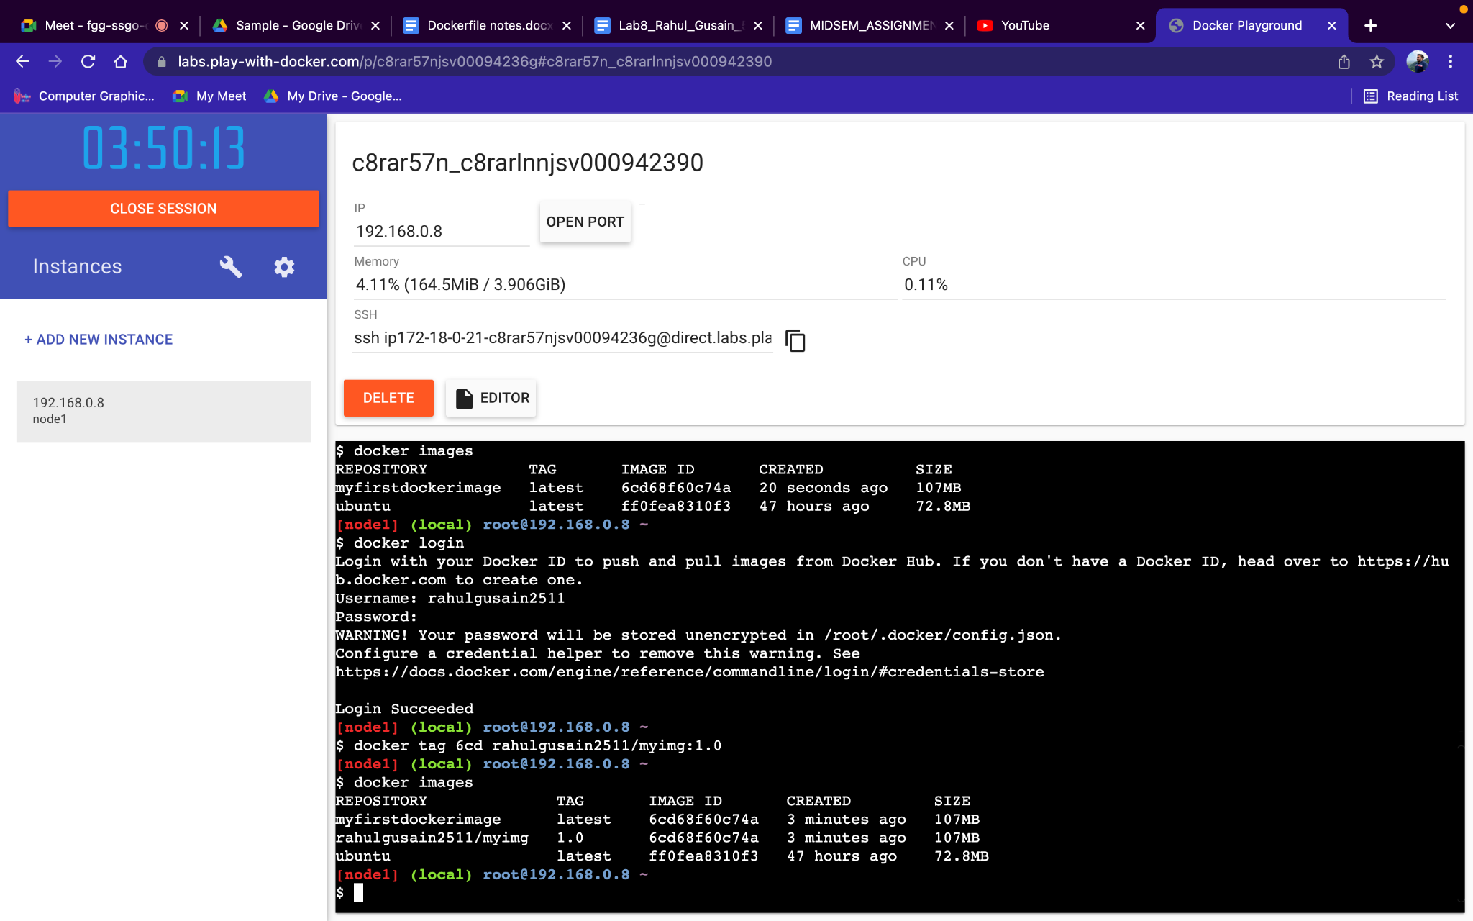

**Step 8**− Now we will use docker push command along with the image id of the image which we wish to push our image to dockerhub which is a centralized location.

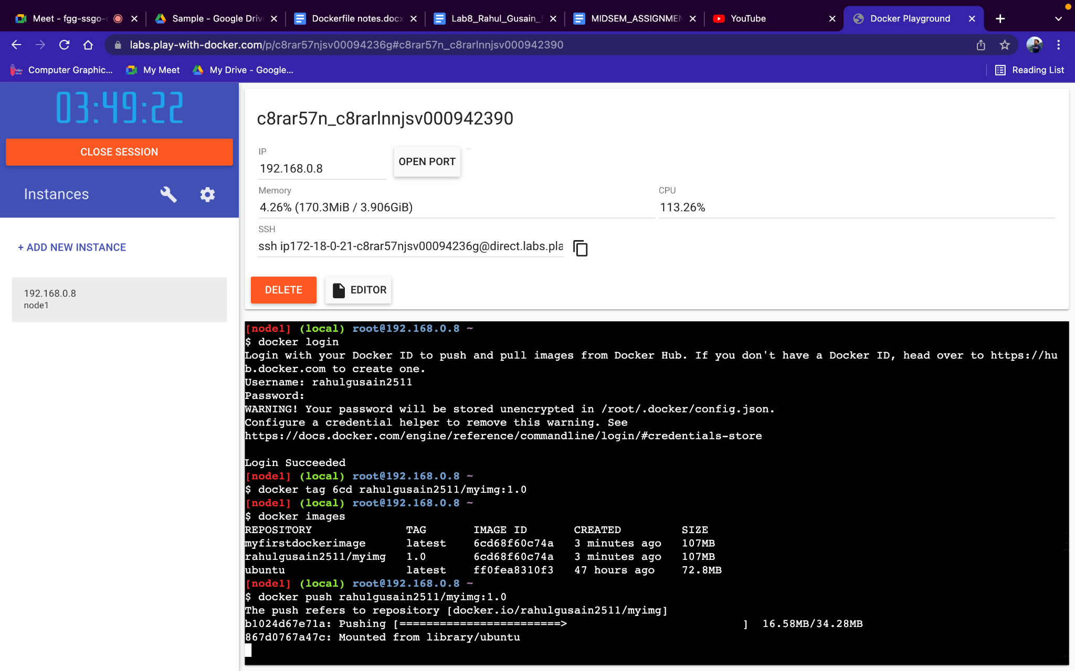

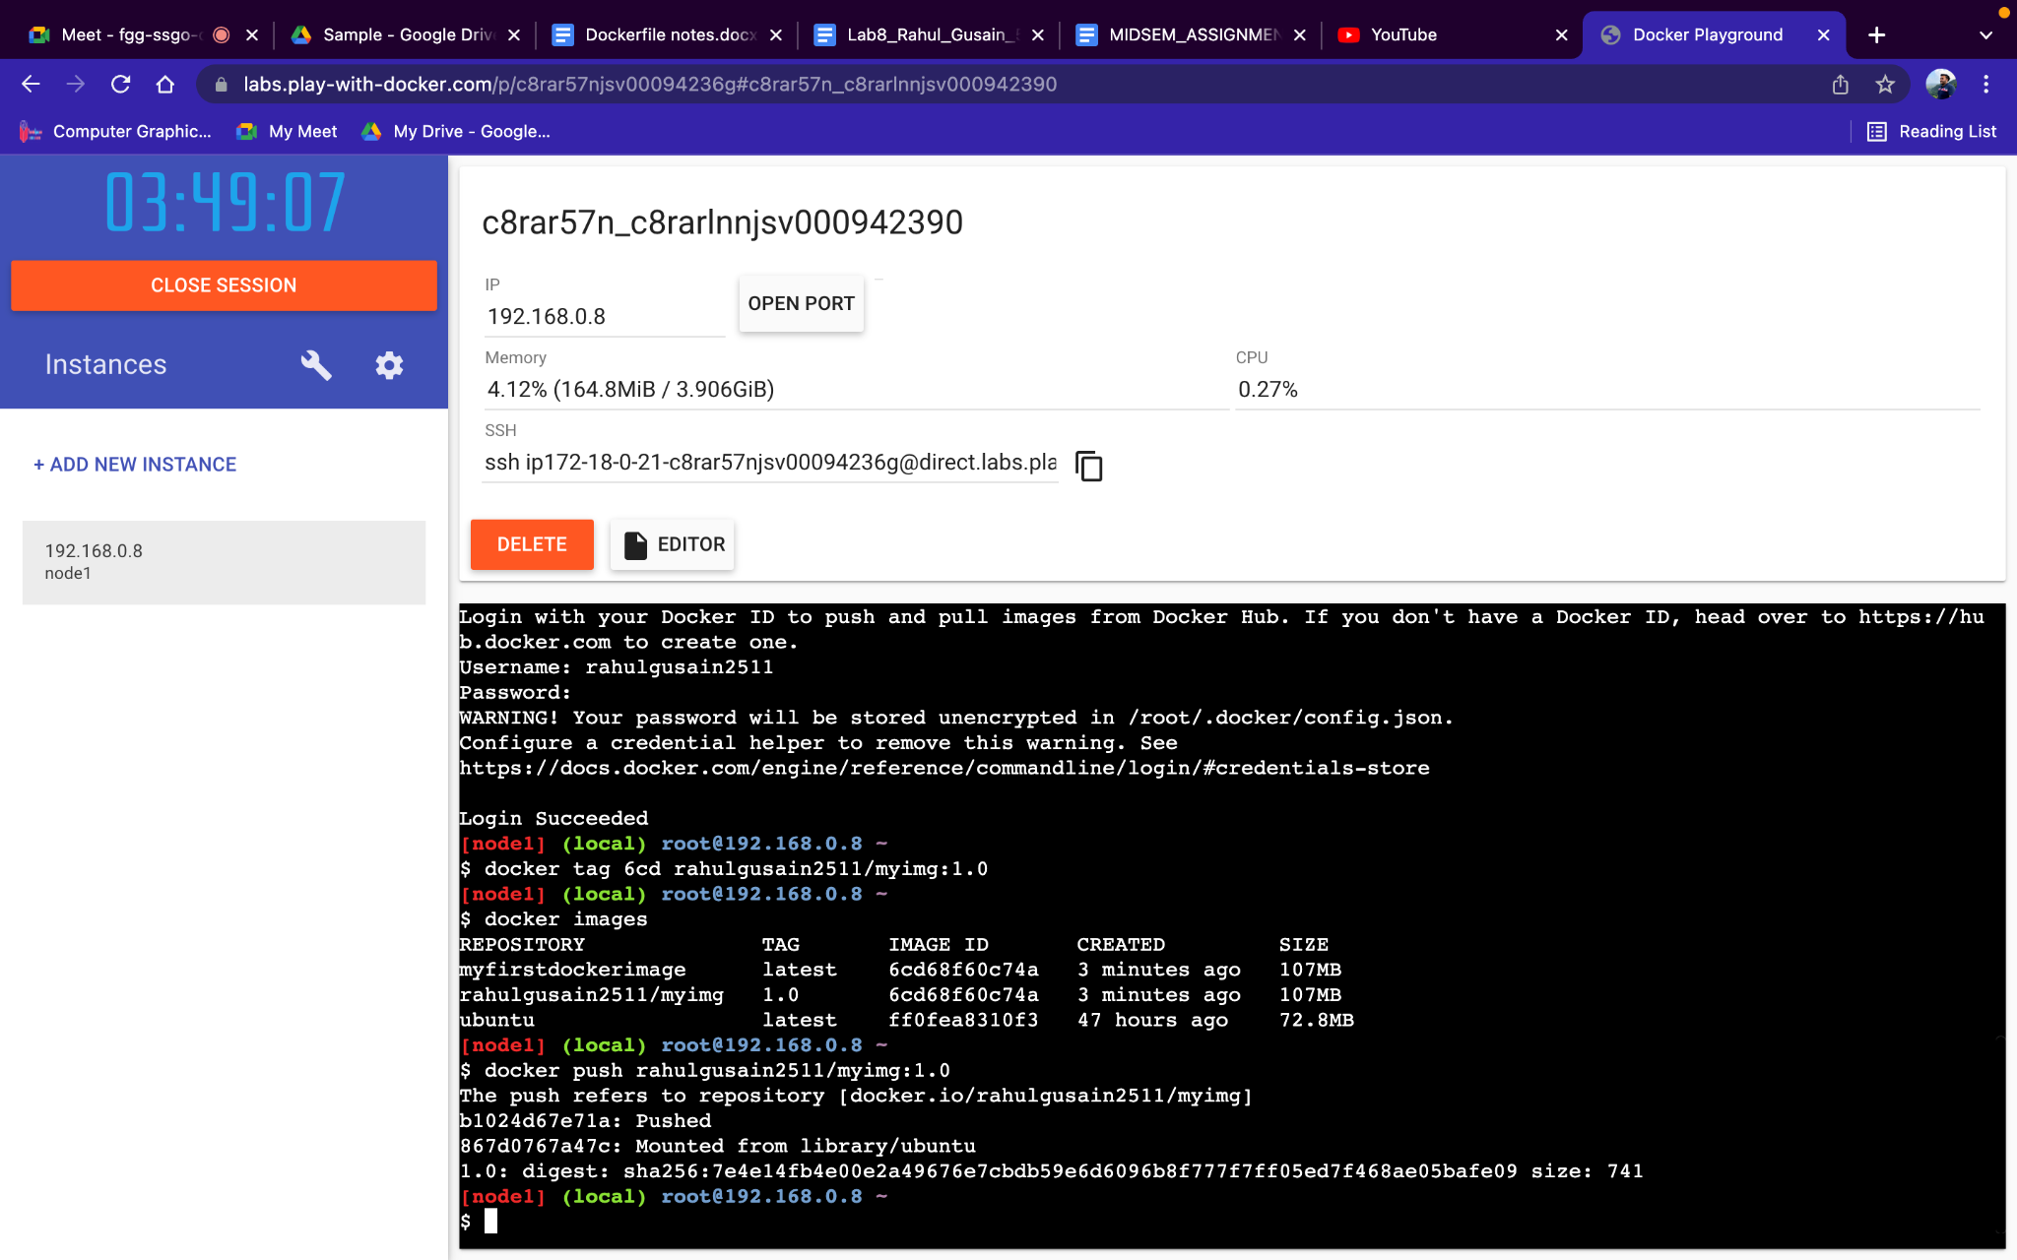

**Step 9**− Now go to the dockerhub account to check whether the image is pushed or not.

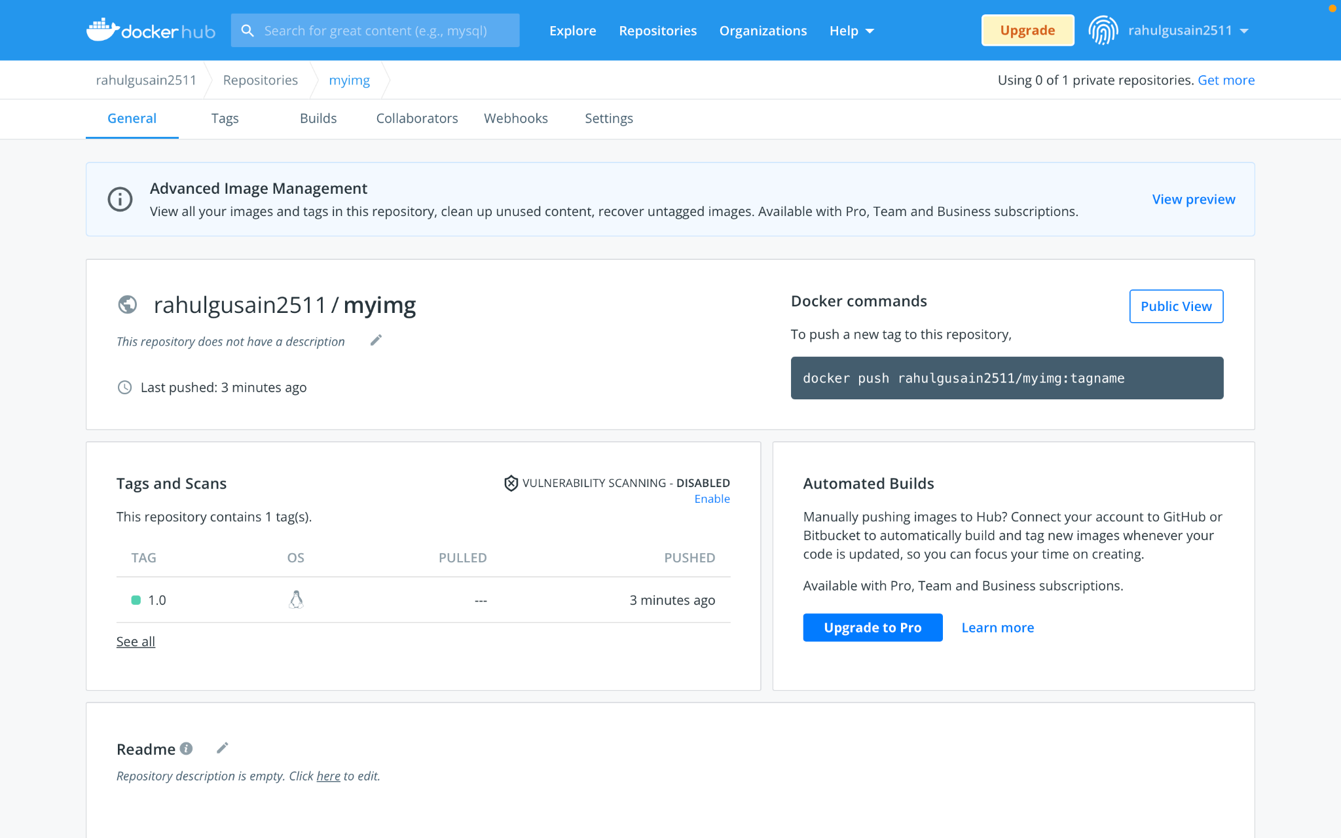

**Step 10**− Use a new instance using Add a new instance button and then use docker login to link this instance to our Dockerhub account.

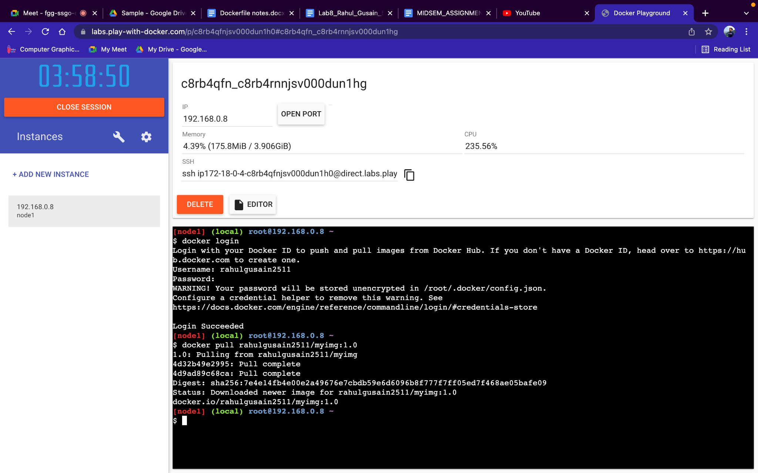

**Step 11**− Use the pull command available on the Dockerhub to pull this newly created image.We get image created at last which shows that the fully functional and can be pulled by anyone anywhere and make use of it.

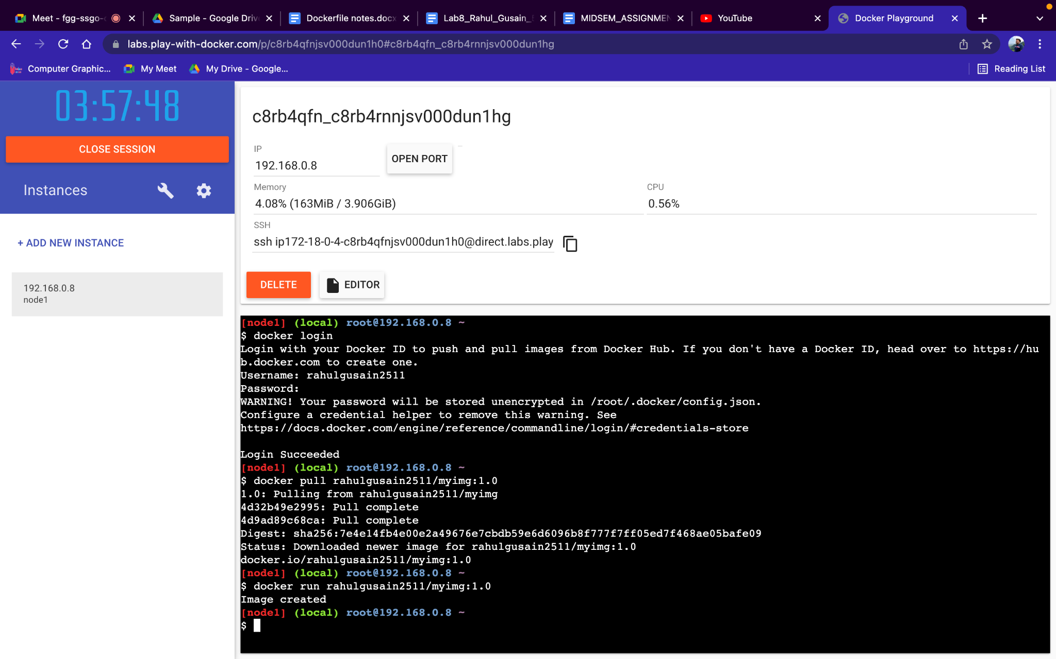

**Command to pull my image :** docker pull rahulgusain2511/myimg